**MINI PROJECT**

**(2019-20)**

**PHARMACY MANAGEMENT SYSTEM**

**MID-TERM REPORT**



**Institute of Engineering & Technology**

**Submitted by-**

**SACHIN TIWARI**

**(171500276)**

## Supervised By

**Mr. Vinay Agarwal Sir**

**Asst. Professor**

**Department of Computer Engineering & Applications**

**Contents**

|  |  |
| --- | --- |
| Abstract | 3 |
| **1.Introduction** | **4** |
| 1.1General Introduction to the topic | 4 |
| 1.2 Area of Computer Science | 5 |
| 1.3 Hardware and Software Requirements | 6 |
| **2.Problem definition** | **7** |
| **3. Objectives** | **8** |
| 4**. Implementation details** | **11** |
| **5. Progress till date & the Remaining work** | **11** |
| **6.Some Screenshots** | **12** |
| **7. References** | **13** |

**Abstract**

Pharmacy management system is one of the most essential tools that are mostly used in hospital; it is mostly used to manage pharmacy related activities such as medical inventory, record keeping, sales management as well as managing the drug stock and information of the expired medicines but it is further modified to be used only by the admin who can store the information of the patient admitted in the hospital and what amount of bill is pending on him . Many hospitals in India are still operating manually; they don’t have adequate software to manage their daily activities. It needs the pharmacist assistant to check the expired date of the medicine twice a week, and it can take a lot of time to find out whether certain medicine are out of stock or also check the patient’s total amount to be deposited. In this project we tried to develop a computerised and web based Pharmacy management system. Our main intention is to allow this application to be used in most hospitals in India, where a small point of customization will be required to each hospital in the implementation period. This system is designed to overcome all challenges related to the management of medicine and management of patient records that were used to be handled locally and manually. Pharmacy management system has its own significance to the hospitals in India. Using this system, it will help us to records all transaction made at the daily sales, recognise all debtors, customers, employees, balance stock, etc. It will manage all activities around the shop that increases productivity and maximize profit, it will also minimizing the risk of getting loss because all transactions are recorded to the system.

**Introduction**

* 1. **General Introduction to the topic**

The main purpose of the Pharmacy Management System is to manage the details of the Patient, Medicines , Stocks, Inventory , Pharmacy , Sells.It manages all the information about the Patient, Medicines ,Company ,Sells .The project is totally built at Administrative end and thus only the Administrator is gauranteed the access.The purpose of the project is to build to an application program to reduce the manual work for managing the Patient’s record, Medicines,Stocks,Company,Inventory.It tracks all the details about the Hospital,Inventory,Pharmacy,Sells.

* 1. **Area of Computer Science**

Mianly there are three parts of coding related frames in our project:

1.Login Page

2.Patient Registration System

3.Hospital Management System

Python is a multi-paradigm programming language. Object-oriented programming and structured programming are fully supported, and many of its features support functional programming and aspect-oriented programming (including by metaprogramming and metaobjects (magic methods)). Many other paradigms are supported via extensions, including design by contract and logic programming.

Python uses dynamic typing, and a combination of reference counting and a cycle-detecting garbage collector for memory management. It also features dynamic name resolution (late binding), which binds method and variable names during program execution.

Python's design offers some support for functional programming in the Lisp tradition. It has filter, map, and reduce functions; list comprehensions, dictionaries, sets and generator expressions. The standard library has two modules (itertools and functools) that implement functional tools borrowed from Haskell and Standard ML

**1.3.Hardware Requirements**

* Memory [1GB RAM (or higher)]
* Intel core i3 64-bit Processor (or higher)
  1. **Software requirements**
* PyCharm
* Any OS

**Objective**

The main objectives of the Pharmacy Management System are as follow:

1. Provides registration facilities of the patient admitting in the Hospital.
2. Pharmacy Management System also manages the sells details online for company details,Inventory details,Pharmacy.
3. Manages the information of Medicines.
4. Shows the information and description of the Pharmacy,Stocks.
5. To increase the efficiency of managing the Pharmacy,Medicines.
6. It reviews and print the bill outstanfing upon the patient.
7. Manages the information of the Pharmacy.
8. Editing,Adding and updating of records is improved which results in proper resource management of Pharmacy Data.
9. Manage the information of the Hospital.
10. Integration of all records of Hospitals.

**Implementation details**

The project consists of mainly three windows or frames:

1.Login Page

2.Patient Registration System

3.Hospital Management System

* Login Page or the main page consists of mainly the part where only the admin can login securely inside the page. If login is unsuccessful user can reset the password or can directly exit the system. If login is successful, admin is given the right to go to the pages which consists of the Patient registration System and the Hospital Management System.
* In the Patient Registration System admin is given the right to register the patient or can review the bill pending on him during his admission in the hospital.
* In the Pharmacy Management System, the admin can review the stock of medicines purchased or can also review the medicine stock remaining. The admin can also review and print the medicine bill of a particular patient.

**Progress**

* Firstly about 95% of the work on Login Page is completed.

Username and password section is the only part of the login page on which some amount of work is left.

* Work on Patient Management System page is under progress and requires some time.
* About 40%of work is done on the Hospital Management System Page but still it requires some time for perfection.
* Documentation:Synopsis and Mis-Term report is completed and submitted.

**SCREENSHOTS**

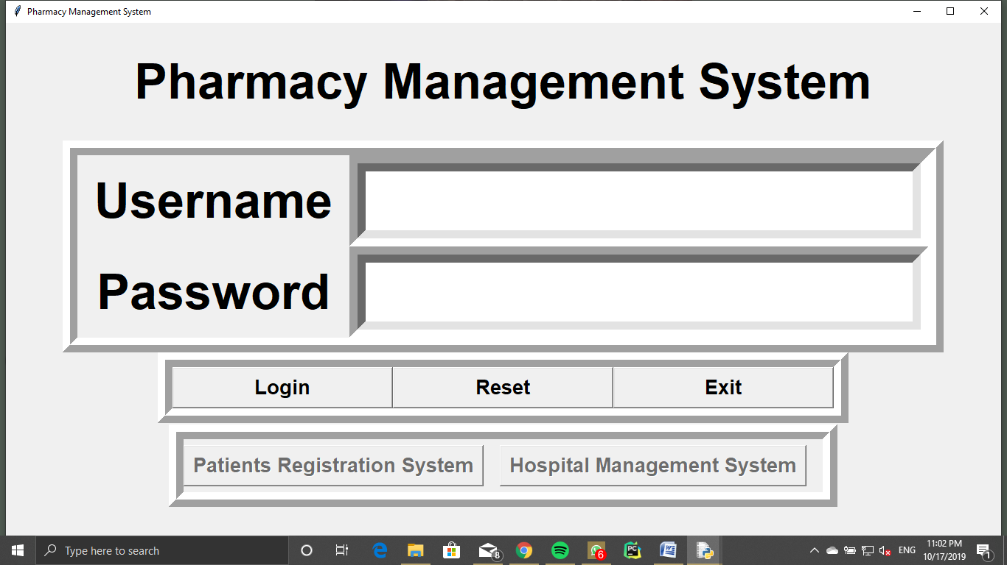

**Interface Of Login Page**

**References**

* <https://www.w3schools.com/python/>
* <https://docs.python.org/3/library/random.html>
* <https://www.tutorialspoint.com/python/python_gui_programming.htm>